E-Commerce Database Project Documentation

Aggregation

- SELECT SUM(stock) FROM products;

- SELECT SUM(price) FROM products;

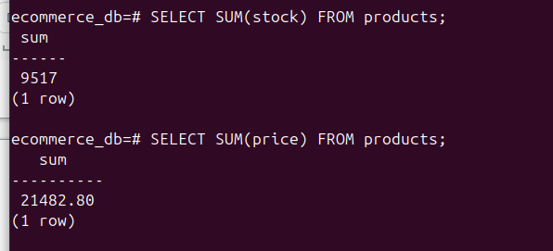
- SELECT AVG(price) FROM products;

- SELECT MAX(price), MIN(price) FROM products;

